Description of test | Test data to be used | Expected Out come | Actual outcome | Comments and intended actions | Date tested
Hotel booking Seeing if all rooms display correctly | Feb 3rd-Feb 8th  Default people  (1 Adult)  Default Filter (HighToLow) | Two rooms should show up as both are available during those dates. | Two rooms show up: Room1 and Room2 | PASS | 03/02/2026
Hotel booking Filtering rooms by capacity | Feb 3rd- Feb 8th  Default people  (1 Adult)  Default Filter (HighToLow) | Only Room 3 to show, as it has enough capacity for 5 people | No room shows when I click the button | FAIL  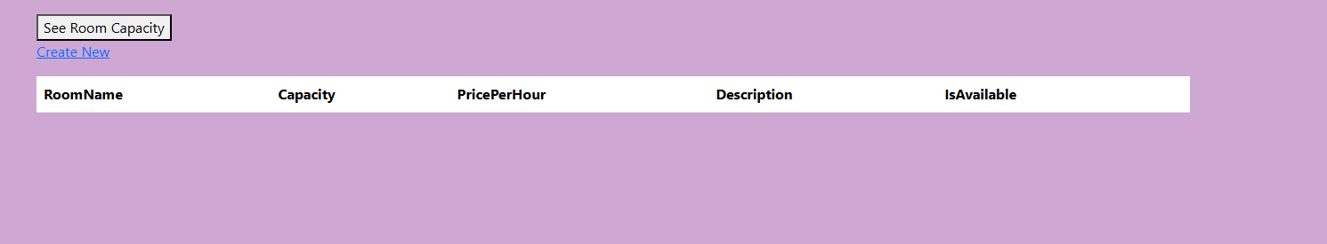  FIX  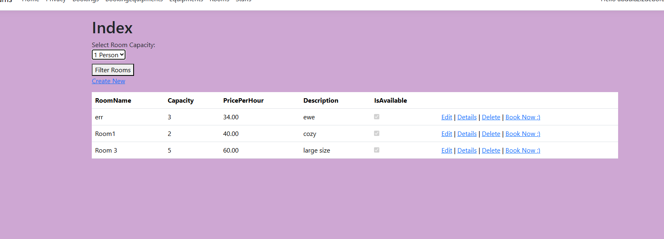  PASS | 03/02/2026
Home page Loading Correctly | Feb 3rd-Feb 8th  Default people  (1 Adult)  Default Filter (HighToLow) | Default browser Page should load with no errors. | Home page loads correctly | PASS  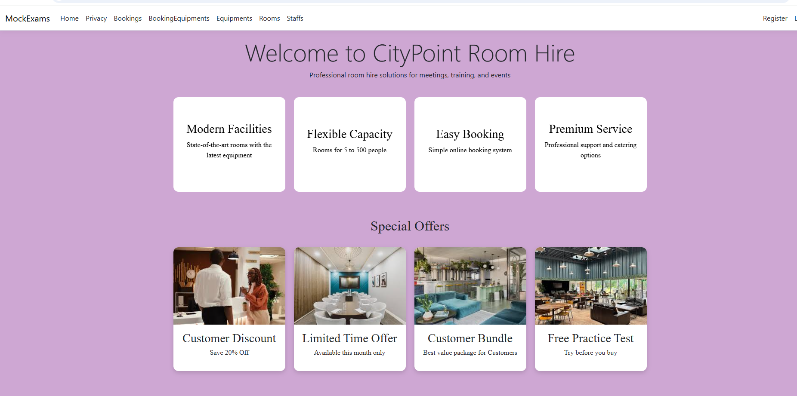 | 06/02/2026
Navigation menu links working | Feb 3rd-Feb 8th  Default people  (1 Adult)  Default Filter (HighToLow) | Click all navigation links Default user | All links open correct pages and the user is able to redirect from any page | PASS | 06/02/2026
Room Search  Sort rooms by price | Feb 3rd-Feb 8th  Default people  (1 Adult)  Default Filter (LowToHigh) | The cheapest room should appear first in the result | The cheapest room appears first in the result | PASS  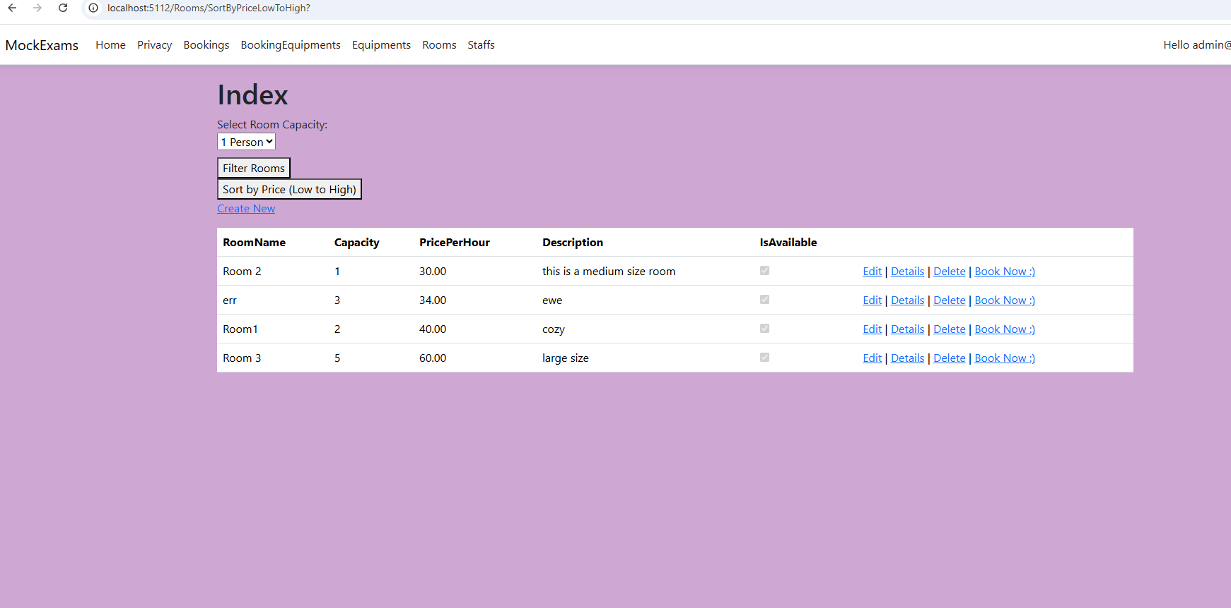 | 06/02/2026
Room Images Image carousel display | Feb 3rd-Feb 8th  Default people  (1 Adult) | Room images should load and rotate within the carousel | Room images loads and rotate within the carousel | PASS | 06/02/2026
Booking Calendar  Highlight current date | Feb 3rd-Feb 8th  Default people  (1 Adult)  Default Filter (HighToLow) | Current date should be highlighted and labelled “Today” | Today’s date is highlighted and labelled correctly | PASS  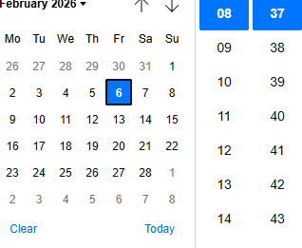 | 06/02/2026
Booking Form Invalid people input | Feb 3rd-Feb 8th  Default people  (1 Adult) | System should reject negative values and display an error | An adequate error is display when a negative value is typed | PASS  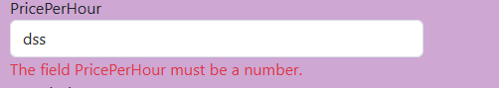 | 06/02/2026
Authentication  Login with valid credentials | Feb 3rd-Feb 8th  Default people  (1 Adult)  User name  admin@admin.com  Password  Admin123! | User should be authenticated and redirected to the home page | User logged in and redirected successfully | PASS  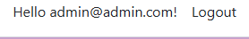 | 06/02/2026
Authorization Access admin-only pages as non-admin | Feb 3rd-Feb 8th  Default people  (1 Adult) | User should be denied access and redirected to login | Access denied and redirect occurs | PASS  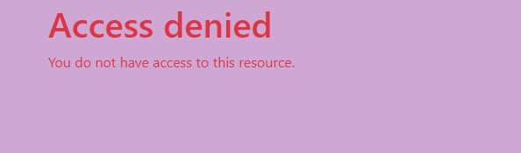 | 06/02/2026
Responsive Design Home page layout | Feb 3rd-Feb 8th  Default people  (1 Adult) | Layout adapts correctly on all screen sizes | Layout adapts on all screen sizes | PASS | 06/02/2026
Responsive Design Privacy Policy | Feb 3rd-Feb 8th  Default people  (1 Adult) | Layout adapts correctly on all screen sizes | Layout adapts on all screen sizes | PASS  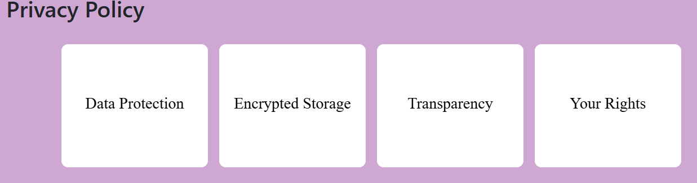 | 06/02/2026
Accessibility Check if the main landing page scales to the user’s screen | Inspect element device toolbar | For Desktop, Tablet and mobile the page and its content should scale and change position to fit neatly within the screen space | The page neatly switches layouts depending on the user’s device | PASS | 06/02/2026
Accessibility Check if the bookings page scales to the user’s screen | Inspect element device toolbar | For Desktop, Tablet and mobile the page and its content should scale and change position to fit neatly within the screen space | The page neatly switches layouts depending on the user’s device | PASS | 06/02/2026
Accessibility Check if the Rooms page scales to the user’s screen | Inspect element device toolbar | For Desktop, Tablet and mobile the page and its content should scale and change position to fit neatly within the screen space | The page neatly switches layouts depending on the user’s device | PASS | 06/02/2026
Accessibility Check if the Equipment page scales to the user’s screen | Inspect element device toolbar | For Desktop, Tablet and mobile the page and its content should scale and change position to fit neatly within the screen space | The page neatly switches layouts depending on the user’s device | PASS | 06/02/2026
Accessibility Check if the Privacy Policy page Scales to the user’s Screen | Inspect element device toolbar | For Desktop, Tablet and mobile the page and its content should scale and change position to fit neatly within the screen space | The page neatly switches layouts depending on the user’s device | PASS | 06/02/2026
Accessibility Check if the Equipment Bookings page Scales to the user’s Screen | Inspect element device toolbar | For Desktop, Tablet and mobile the page and its content should scale and change position to fit neatly within the screen space | The page neatly switches layouts depending on the user’s device | PASS | 06/02/2026
Accessibility Check if the Staffs page Scales to the user’s Screen | Inspect element device toolbar | For Desktop, Tablet and mobile the page and its content should scale and change position to fit neatly within the screen space | The page neatly switches layouts depending on the user’s device | PASS | 06/02/2026
Navigation button Clicking on “Home” in the nav bar | Default people  (1 Adult) | The website navigates the user to the landing page | The website navigates the user to the landing page | PASS | 06/02/2026
Navigation button Clicking on “Privacy” in the nav bar | Default people  (1 Adult) | The button navigates the user to the privacy Policy page | The button  navigates the user to the privacy policy page | PASS | 06/02/2026
Navigation button Clicking on “Bookings” in the nav bar | Default people  (1 Adult) | The button navigates the user to the Bookings page | The button navigates the user to the Bookings page | PASS | 06/02/2026
Navigation button Clicking on “Booking Equipment” in the nav bar | Default people  (1 Adult) | The button navigates the user to the Booking Equipment page | The button navigates the user to the Booking Equipment page | PASS | 06/02/2026
Navigation button Clicking on “Equipment’s” in the nav bar | Default people  (1 Adult) | The button navigates the user to the Equipment’s page | The button navigates the user to the Equipment’s page | PASS | 06/02/2026
Navigation button Clicking on “Rooms” in the nav bar | Default people  (1 Adult) | The button navigates the user to the Rooms page | The button navigates the user to the Rooms page | PASS | 06/02/2026
Navigation button Clicking on “Staffs” in the nav bar | Default people  (1 Adult) | The button navigates the user to the Staffs page | The button navigates the user to the Staffs page | PASS | 06/02/2026
Navigation button Clicking on “Delete Rooms” in the room’s web page | Default people  (1 Adult) | The button Deletes the lists of rooms selected on the Room’s page | The button Deletes the lists of rooms selected on the Room’s page | PASS | 06/02/2026
Navigation button Clicking on “Edit Rooms” in the room’s web page | Default people  (1 Adult) | The button Edits the lists of rooms selected on the Room’s web page | The button Edits the lists of rooms selected on the Room’s web page | PASS | 06/02/2026
Navigation button Clicking on “Details Rooms” in the room’s web page | Default people  (1 Adult) | The button shows the details of the room selected on the Room’s web page | The button shows the details of the room selected on the Room’s web page | PASS | 06/02/2026
Navigation button Clicking on “Create New” in the room’s web page | Default people  (1 Adult) | The button navigates the user to a crate rooms page | The button navigates the user to a crate rooms page | PASS | 06/02/2026
Navigation button Clicking on “Book Now” in the room’s web page | Default people  (1 Adult) | The button navigates the user from the room page to the bookings page and ask the user to fill in the required details and then book a room | The button navigates the user to the bookings page and book a room | PASS | 06/02/2026
Navigation button Clicking on “Edit” in the Booking’s web page | Default people  (1 Adult) | The button navigates the user to the edit page so the user can edit a booking | The button navigates the user to the edit page so the user can edit a booking | PASS | 06/02/2026
Navigation button Clicking on “Details” in the Booking’s web page | Default people  (1 Adult) | The button navigates the user to the Room Booking Details page so that the user can see details of the booking | The button navigates the user to the Room Booking Details page so that the user can see details of the booking | PASS | 06/02/2026
Navigation button Clicking on “Delete” in the Booking’s web page | Default people  (1 Adult) | The button navigates the user to the Room Bookings Delete page | The button navigates the user to the Room Bookings Delete page and the user is able to delete a booking | PASS | 06/02/2026
Navigation button Clicking on “Create New” in the bookings’ web page | Default people  (1 Adult) | The button should not work cause you need to be able to create a booking by clicking the book now button in the Rooms page | The button does not work and navigates the user to the rooms page | PASS | 06/02/2026
Navigation button Clicking on “Delete” in the Booking Equipment’s web page | Default people  (1 Adult) | The button navigates the user to the Booking Equipment’s Delete page | The button navigates the user to the Booking Equipment’s Delete page and the user is able to delete a booking | PASS | 06/02/2026
Navigation button Clicking on “Details” in the Booking Equipment’s web page | Default people  (1 Adult) | The button navigates the user to the Booking Equipment’s Details page | The button navigates the user to the Booking Equipment’s Details page | PASS | 06/02/2026
Navigation button Clicking on “Edit” in the Booking Equipment’s web page | Default people  (1 Adult) | The button navigates the user to the Booking Equipment’s Edit page | The button navigates the user to the Booking Equipment’s Edit page | PASS | 06/02/2026
Navigation button Clicking on “Create New” in the Booking Equipment’s web page | Default people  (1 Adult) | The button should not work cause you need to be able to create a booking by clicking the book now button in the Equipment’s page | The button does not work and navigates the user to the Equipment’s page | PASS | 06/02/2026
Navigation button Clicking on “Delete” in the Equipment’s web page | Default people  (1 Adult) | The button navigates the user to the Equipment’s Delete page | The button navigates the user to the Equipment’s Delete page | PASS | 06/02/2026
Navigation button Clicking on “Edit” in the Equipment’s web page | Default people  (1 Adult) | The button navigates the user to the Equipment’s Edit page | The button navigates the user to the Equipment’s Edit page | PASS | 06/02/2026
Navigation button Clicking on “Details” in the Equipment’s web page | Default people  (1 Adult) | The button navigates the user to the Equipment’s Details page | The button navigates the user to the Equipment’s Details page | PASS | 06/02/2026
Navigation button Clicking on “Create New” in the Equipment’s web page | Default people  (1 Adult) | This button navigates the user to the create Equipment page | This button navigates the user to the create Equipment page | PASS | 06/02/2026
Navigation button Clicking on “Book Now” in the Equipment’s web page | Default people  (1 Adult) | This button navigates the user to the booking Equipment’s page allowing the user to book an equipment | This button navigates the user to the booking Equipment’s page allowing the user to book an equipment | PASS | 06/02/2026
Navigation button Clicking on “Delete” in the Staff’s web page | Default people  (1 Adult) | This button navigates the user to the Delete Staff roles page | This button navigates the user to the Delete Staff roles page | PASS | 06/02/2026
Navigation button Clicking on “Details” in the Staff’s web page | Default people  (1 Adult) | This button navigates the user to the Details Staff roles page | This button navigates the user to the Details Staff roles page | PASS | 06/02/2026
Navigation button Clicking on “Edit” in the Staff’s web page | Default people  (1 Adult) | This button navigates the user to the Edit staff’s role page | This button navigates the user to the Edit staff’s role page | PASS | 06/02/2026
Navigation button Clicking on “Create New” in the Staff’s web page | Default people  (1 Adult) | This button navigates the user to a create staff role page | This button navigates the user to a create staff role page | PASS | 06/02/2026

